

CyPERS
BRD05 – NURSING INFORMATION SYSTEM
Use Case v1.0



Nov 27, 2010
Authored by:
Ignis Technology Solutions Private Ltd.

Information contained in this document is classified Ignis Technology Solution Private Ltd... Confidential Proprietary. Only authorized Ignis Technology Solutions Private Ltd. personnel shall have access to the information contained in this document unless business needs dictate, otherwise. It is the responsibility of the person knowing the information contained in this document to ensure confidentiality of information contained in it and securing this document from unauthorized access at all times.
DOCUMENT INFORMATION
Author | Ajay Agrawal
Reviewer
Approver
Approved Date

CHANGE HISTORY
Version # | Release Date | Sections Changed | Author | Change Description
0.1 | Nov 27, 2010 | All | Ajay Agrawal | Draft Version

Acronyms
Acronym | Definition
CMS | Care Management System
CyPERS | Cyber patient electronic record system
ADTR | Admission, Discharge, Transfer and Registration
ME | Management Executive

Table of Contents

1.Introduction 4
2.Use Cases 4
2.1. Use Case Model 4
2.2. UC 5.1 Add patient in Nurses list 4
2.2.1 Functional Requirements 4
2.2.2 Basic WorkFlow 4
2.2.3 Screen Layout 5
2.3. UC 5.2 Display TODO List 5
2.3.1 Functional Requirements 5
2.3.2 Basic WorkFlow 6
2.3.3 Screen Layout 7
2.4. UC 5.3 Doctor’s Verbal Orders 8
2.4.1 Functional Requirements 8
2.4.2 Basic WorkFlow 8
2.4.3 Screen Layout 8
2.5. UC 5.4 Shift Handover 10
2.5.1 Functional Requirements 10
2.5.2 Assumption 10
2.5.3 Basic WorkFlow 10
2.5.4 Screen Layout 10
2.6. UC 5.5 Documentation of scheduled medication order 11
2.6.1 Functional Requirements 11
2.6.2 Assumption 12
2.6.3 Screen Layout 12
2.7. UC 5.6 Documentation of scheduled others order 12
2.7.1 Functional Requirements 13
2.7.2 Assumption 13
2.7.3 Screen Layout 13
2.8. UC 5.7 Patient comprehensive chart of vital signs 14
2.8.1 Functional Requirements 14
2.8.2 Assumption 14
2.8.3 Screen Layout 14
2.9. UC 5.8 Individual patient vital charting 15
2.9.1 Functional Requirements 15
2.9.2 Assumption 16
2.9.3 Screen Layout 16
2.10. UC 5.9 Nursing assessment form 17
2.10.1 Functional Requirements 17
2.10.2 Assumption 17
2.10.3 Screen Layout 17

Introduction
The NIS allows patient management by nurses. Nurses are able to view relevant clinical data, enter their assessments and formulate their plan of care based on standard templates. Doctors’ orders are displayed and nurses document acknowledgement and compliance with orders.

Use Cases

Use Case Model

UC 5.1 Add patient in Nurses list
Use Case No. | CyPERS/UC/5.1
Name | Add Patient in Nurses TODO List
Actors | Nurses
Description | Nurse can add the patient based on the location, doctor or the specialty
Trigger
Pre Conditions | - Nurse has logged into the system  - Nurse click on the search and add icon in the footer

Functional Requirements
No. | Description
5.1FR1.0 | Nurse should be able to add the patient based on the doctor
5.1FR2.0 | Nurse should be able to add patient based on the doctor specialty
5.1FR3.0 | Nurse should be able to add patient based on the location and should also able to add the vacant bed in their list i.e. once the bed get occupied by any patient then automatically the patient should get add into her list.
5.1FR4.0 | Nurse should be able to add patient from different criteria at a same time such as from doctor, specialty, and location.

Basic WorkFlow
Flow 1

- Nurse clicks on the search and add icon available in the footer
- Nurse selects a doctor in a list and the entire senior doctor list populate in another drop down.
- Nurse select single or multiple doctor from the list and click add
- All the patient of the selected doctor get add in the nurse to do list and the nurse TODO list get refresh with the new data.
Flow 2
- Nurse clicks on the search and add icon available in the footer
- Nurse selects a Specialty in a list and the different specialty populate in another drop down.
- Nurse select single or multiple specialty from the list and click add
- All the patient of the selected specialties doctor gets add in the nurse to do list and the nurse TODO list get refresh with the new data.
Flow 3
- Nurse clicks on the search and add icon available in the footer
- Nurse selects a bed category in a list and the different location of the bed category populate in another drop down.
- If user select a location and click on add then all the patient of the selected location beds will get add in to their list.
- If user select a location and all the beds available in that location get populate in to another drop down and nurse can select multiple beds from the list and add the patient of that bed into their list.
Note: in this scenario all the existing patient list will get add with the new patient list.

Screen Layout
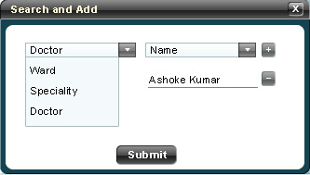

UC 5.2 Display TODO List
Use Case No. | CyPERS/UC/5.2
Name | Display Nurse TODO List
Actors | Nurses
Description | Nurse can see the all the patient in their TODO List
Trigger | Doctor orders for nursing or other category of order from the order screen in Doctor information system module.
Pre Conditions | - Nurse has logged into the system

Functional Requirements
No. | Description
5.2FR1.0 | Nurse should see the all her patient in her TODO list in tabular format
5.2 FR2.0 | When a doctor enters New Orders for a patient:  The name of the patient changes color to different color till the nurse has viewed  The order by acknowledging it. It will then change back to usual color
5.2FR3.0 | If the doctor has also entered any order with a “stat” priority:  The name of the patient will blink till the nurse has viewed the order by  acknowledging it
5.2FR4.0 | Scheduled Order: The relevant icon will blink in the relevant time column &  Nurse will click on it
5.2FR5.0 | Based on the doctor order the different icon will placed against the time lime for each patient
5.2FR6.0 | If a new patient is admitted on the vacant bed which is allotted to the nurse then on every doctor order the patient name will add into her list automatically
5.2FR7.0 | The nurse TODO list should refresh every 5 min and load the current data in to her list
5.2FR8.0 | The time column(s) for the icon depends on the “Priority” or Scheduled Time & Date  Stat - In the current time column  Urgent – 2 hours from now  Routine- Next Day Morning at 6:00 AM for Lab, 8:00AM for all others
5.2FR9.0 | For Medications, the icon appears at following intervals based on the “Frequency”. It would also appear in the current time column if a stat order is entered. Please refer the Table 1.0 Below
5.2FR10.0 | If a particular task is not done within 48 hours, it will appear in the “pending tasks” column of the nurse screen.

Basic WorkFlow
Icon Placement Logic
- Icons appear based on the orders given by doctors
- Only one icon appears in a column for any number of same category orders
- For example, if 1 drug order is given for 8 Am & two drug orders for 8 PM, then only one pill icon will appear in 8 AM column and one pill icon in 8 PM column
- If Lab test is ordered, the “Test Tube” icon will appear, if Radiology test, then “X--‐Ray” icon
- The “Cap” icon appears if either or any or all of the following are ordered:
- Other Tests, Procedure is scheduled, Steam Nebulization is ordered

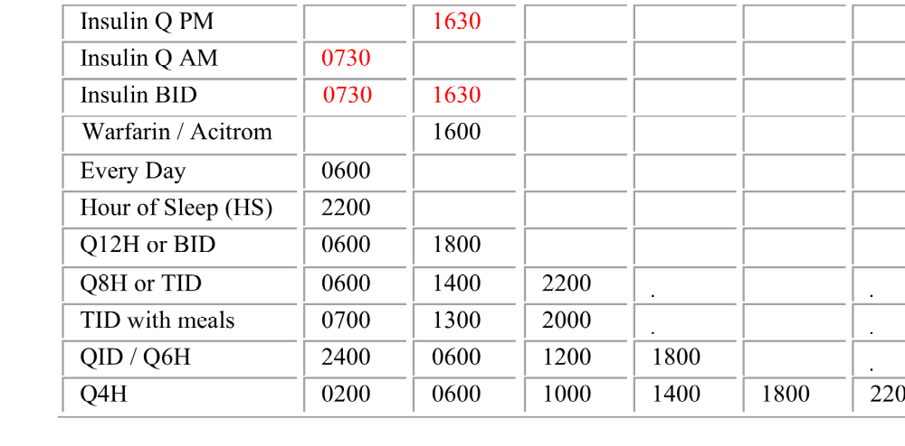
Table 1.0 Medication Icon placement logic against time line

Screen Layout
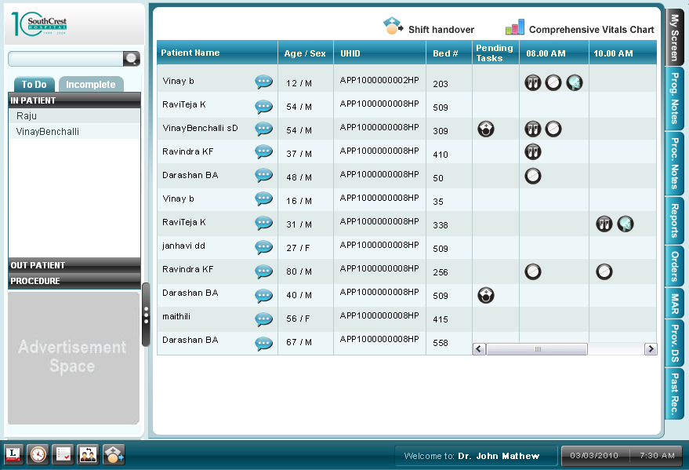

UC 5.3 Doctor’s Verbal Orders
Use Case No. | CyPERS/UC/5.3
Name | Doctor’s Verbal Order
Actors | Nurses, Sr. or Jr. Doctor
Description | This user case capture the verbal order given by the doctor
Trigger | Doctor has given any verbal order which their visit in In-Patient ward
Pre Conditions | Nurse has logged into the system and doctor has given any verbal order

Functional Requirements
No. | Description
5.3FR1.0 | Nurse should be able to capture the verbal order given by the doctor
5.3 FR2.0 | All the verbal order should go to the respective doctor pending list for the approval. This approval is only for the documentation purpose and even without the approval also the order will be effective and valid.
5.3FR3.0 | The verbal order screen would be same as the order screen but it will have another section where nurse can select the doctor name. The request notification should be same as the create order use case. Please refer UC 4.08 Create Orders in BRD04 Doctor information System.
5.3FR4.0 | The doctor list in the verbal order will show only the care providers name (Sr. And Jr. Doctor) who is taking care of the patient.
5.3FR5.0 | Some Organizations may want to disable this option or allow only certain  Category of drugs that nurses can order. Hospital should be able to configure their preference on which the nurse can give order through verbal order.

Basic WorkFlow
- Doctor has given any verbal order to the nurse
- Nurse clicks on the verbal order exists in their TODO Screen beside each patient name
- The order screen load in a pop up
- Nurse selects the doctor name from the drop down and enters the order and click on the save button.
- A notification goes to the respective doctor and displays the verbal order approval request in the Doctor Pending list.

Screen Layout

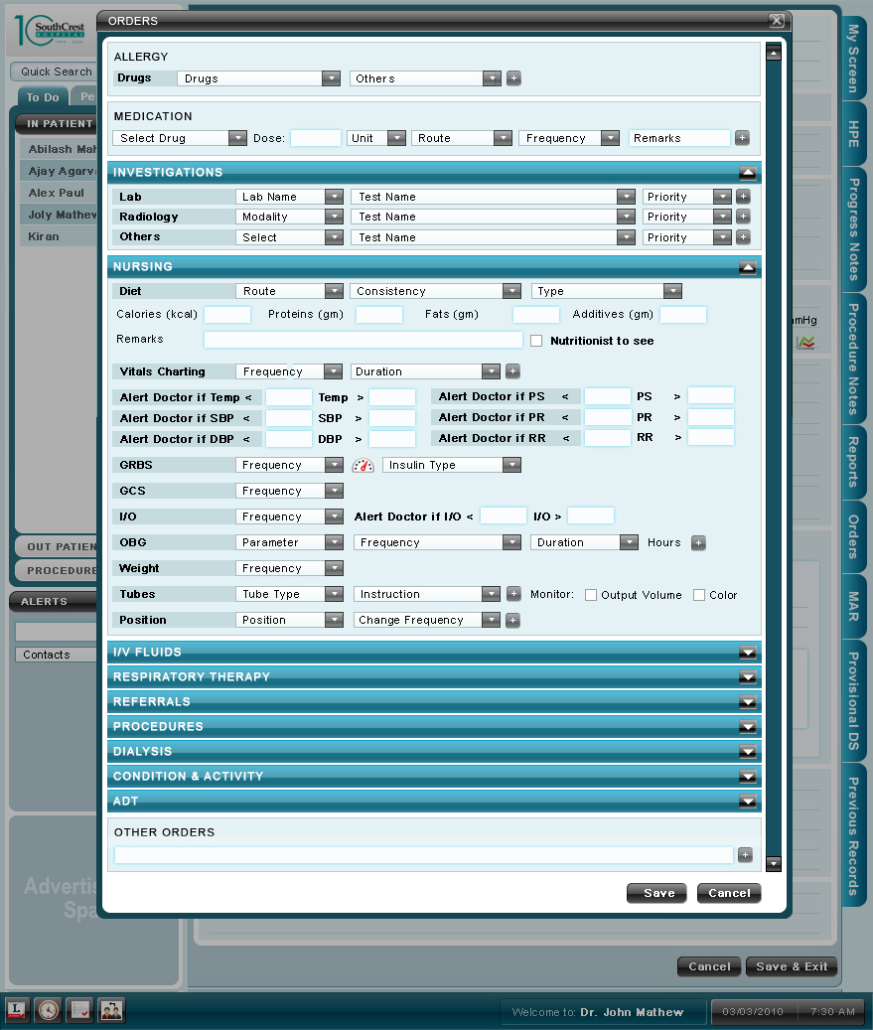

UC 5.4 Shift Handover
Use Case No. | CyPERS/UC/5.4
Name | Shift Handover
Actors | Nurses
Description | This user case capture the verbal order given by the doctor
Trigger | This use case trigger at the time the shift get over of a nurse and other nurse takeover the charge of the patient
Pre Conditions

Functional Requirements
No. | Description
5.4FR1.0 | There should be an icon in the in the Footer to allow nurse to hand over the patient information to the next shift nurse while check out from her shift.
5.4 FR2.0 | Sift handover screen should display the entire patient name with their respective latest vital sign value with the pending investigation/order/patient schedule for procedure in this or next shift in a popup. For same kind of order there should be only icon such as if there are multiple investigation should be done then only one investigation will display.
5.4FR3.0 | The popup should has a accept button
5.4FR4.0 | On acceptance, user will be prompted with the login screen in the same popup where the receiving nurse enter her login credential
5.4FR5.0 | After login a prompt message should display the TODO list of the receiving nurse.

Assumption
The receiving nurse TODO patient list will be replacing with the shift change nurse patient on acceptance. Even if, she was taking care of other patients in her previous shift. And at the same time the future location for this nurse will also being replace with the shift change nurse location.

Basic WorkFlow
- Nurse clicks on the shift handover icon available in the footer
- . The system displays the all the patient whom she is taking care in the popup with their respective vital sigh and the pending task from this shift
- The receiving nurse check the information and click on the accept button
- The system asks for the login credential of the receiving nurse.
- After signing in the system, system loads the TODO list of the receiving Nurse.

Screen Layout
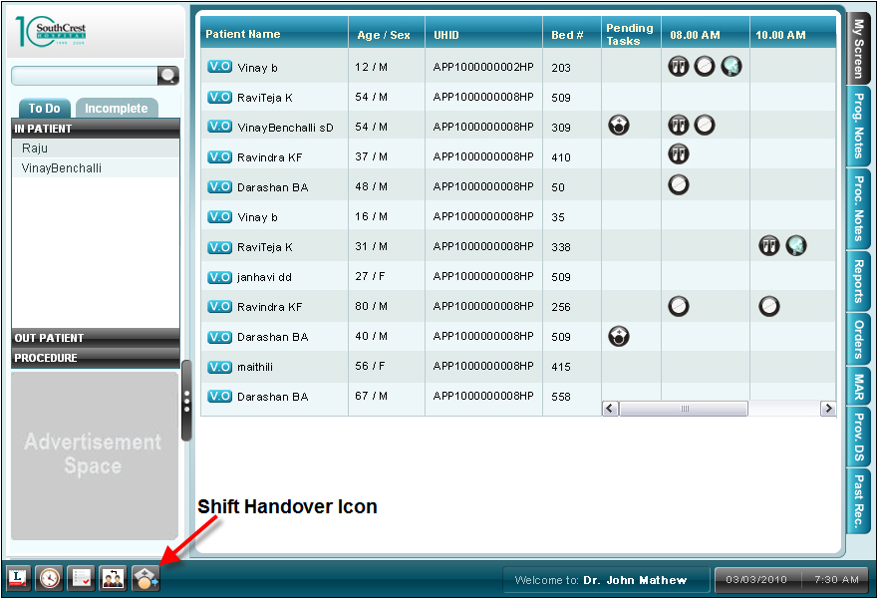

UC 5.5 Documentation of scheduled medication order
Use Case No. | CyPERS/UC/5.5
Name | Documentation of scheduled medication order
Actors | Nurses
Description
Trigger
Pre Conditions

Functional Requirements
No. | Description
5.5FR1.0 | Nurse can document completion / status of task by one click or change the time when the task was done
5.5 FR2.0 | On click of medication icon, all the medication which has to be given to the patient at particular schedule will be display.
5.5FR3.0 | In time column the default value would be the current time, but nurse should be able to change the value if she wants. There should be validation on the time column such as it should not accept the time in wrong format.
5.5FR4.0 | Nurse should be able to save the individual value by clicking the save button in each row but at the same time there should a button called Save All which will save all the data in one go.
5.5FR5.0 | If nurse click on the same medication icon again then the already entered data will appear in the same popup which she can modify if required.

Assumption
N/A

Screen Layout
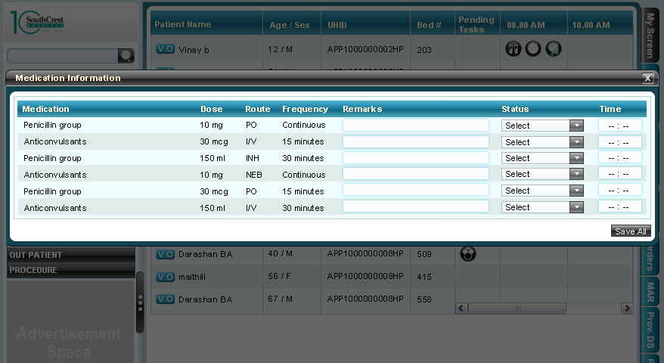

UC 5.6 Documentation of scheduled others order
Use Case No. | CyPERS/UC/5.6
Name | Documentation of scheduled other order
Actors | Nurses
Description
Trigger
Pre Conditions

Functional Requirements
No. | Description
5.6FR1.0 | Nurse can document completion / status of task by one click or change the time when the task was done
5.6 FR2.0 | On click of other icons except the medication, all the other orders which have to be done at particular schedule for that patient will be display.
5.6FR3.0 | In time column the default value would be the current time, but nurse should be able to change the value if she wants. There should be validation on the time column such as it should not accept the time in wrong format.
5.6FR4.0 | Nurse should be able to save the individual value by clicking the save button in each row but at the same time there should a button called Save All which will save all the data in one go.
5.6FR5.0 | If nurse click on the same medication icon again then the already entered data will appear in the same popup which she can modify if required.

Assumption
N/A

Screen Layout
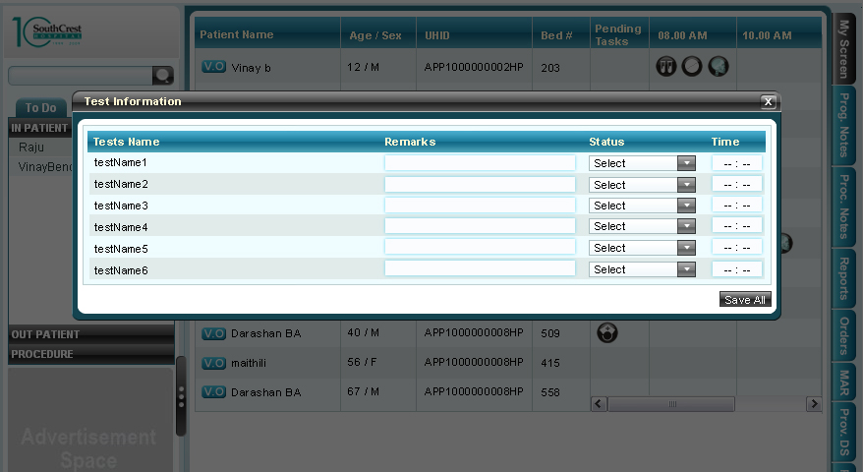

UC 5.7 Patient comprehensive chart of vital signs
Use Case No. | CyPERS/UC/5.7
Name | Patient Comprehensive Charting of Vital sign
Actors | Nurses
Description
Trigger
Pre Conditions

Functional Requirements
No. | Description
5.7FR1.0 | On the TODO screen, there should be a button “Comprehensive Chart”
5.7 FR2.0 | On click of the comprehensive chart button, opens a popup screen for documenting the vital signs of all patients in tabular format at single go.
5.7FR3.0 | On clicking on the respective column heading of different vitals will open the respective comprehensive chart for that parameter.
5.7FR4.0 | The comprehensive chart should be available for only following vitals  GRBS=Diabetic Chart  GCS = Neuro Chart  Temp  RR  SBP  DBP  MAP  PR
5.7FR5.0 | All the value in the vital should be numeric value
5.7FR6.0 | If the vital value is greater than the value Doctor entered in the order screen while giving the order then the alert should go to the doctor.
5.7FR7.0 | The vital information should be sync and all the user in their respective screen will see the latest value entered by any care provider.
5.7FR8.0 | All comprehensive charts are similar:  1st 4 columns are same

Assumption
N/A

Screen Layout
Please refer the attached excel for all kind of charts and the formula required to implement for respective graphs
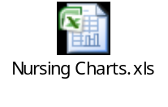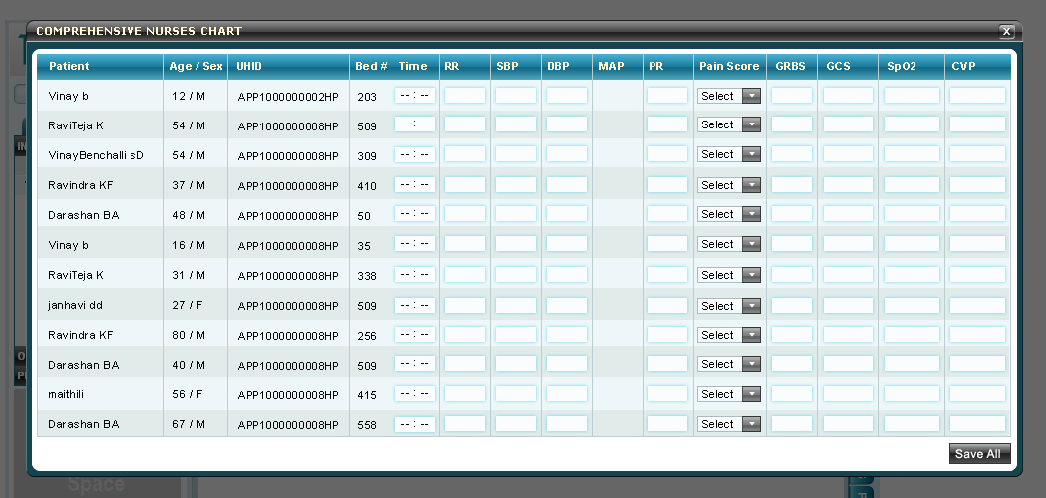

UC 5.8 Individual patient vital charting
Use Case No. | CyPERS/UC/5.8
Name | Individual Patient Vital Charting
Actors | Nurses
Description
Trigger
Pre Conditions

Functional Requirements
No. | Description
5.8FR1.0 | Nurses access the various charts from the section II of NAF
5.8 FR2.0 | The values of Vital Signs are entered directly in the respective fields
5.8FR3.0 | Clicking the I/O opens the Intake/Output Chart
5.8FR4.0 | Clicking the GRBS opens the Diabetic Chart for viewing & documenting
5.8FR5.0 | Clicking the GCS opens the Neuro Chart
5.8FR6.0 | Clicking the SpO2 opens the Respiratory Chart
5.8FR7.0 | Clicking the CVP opens the Cardio Vascular Chart
5.8FR7.0 | The following chart icons are present in the section II & can be accessed to fill the values  – OBG Chart – will open on click of obgGYN  – Restraint Chart – will open on click of SKIN  – Special Care Chart – will open on click of ADL  – Transfer Checklist  – Code Blue – Will open on click of CVS

Assumption
N/A

Screen Layout
Please refer the attached excel for all kind of charts and the formula required to implement for respective graphs
Sample Screen for the Cardiovascular Chart
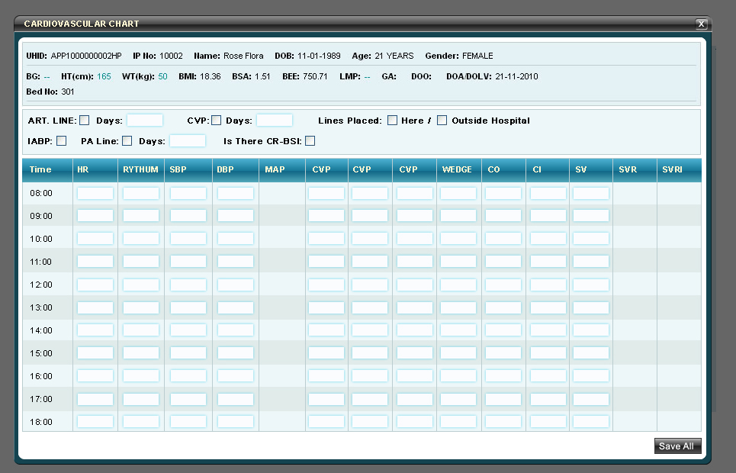

UC 5.9 Nursing assessment form
Use Case No. | CyPERS/UC/5.9
Name | Nursing Assessment Form
Actors | Nurses
Description
Trigger
Pre Conditions

Functional Requirements
No. | Description
5.9FR1.0 | Nurses daily notes are documented in NAF
5.9 FR2.0 | The following sections appear for existing patients:  – Section I  – Section II  – Section III  – Section IV b (relevant section depending on the age)  – Section V
5.9FR3.0 | Section IV a appears only for new patients
5.9FR4.0 | The options for the various fields are in the document “Nursing Field Options”
5.9FR5.0 | Fall Risk & Braden Score are calculated based on choices entered & calculated as per scores given in brackets in the field option sheet

Assumption
N/A

Screen Layout
